Nama : Abdi Akhsanul Afkar

NIM : 18090048

Kelas : 5C

PRAKTEK W4

1. Source Code

Web.php - application/controller

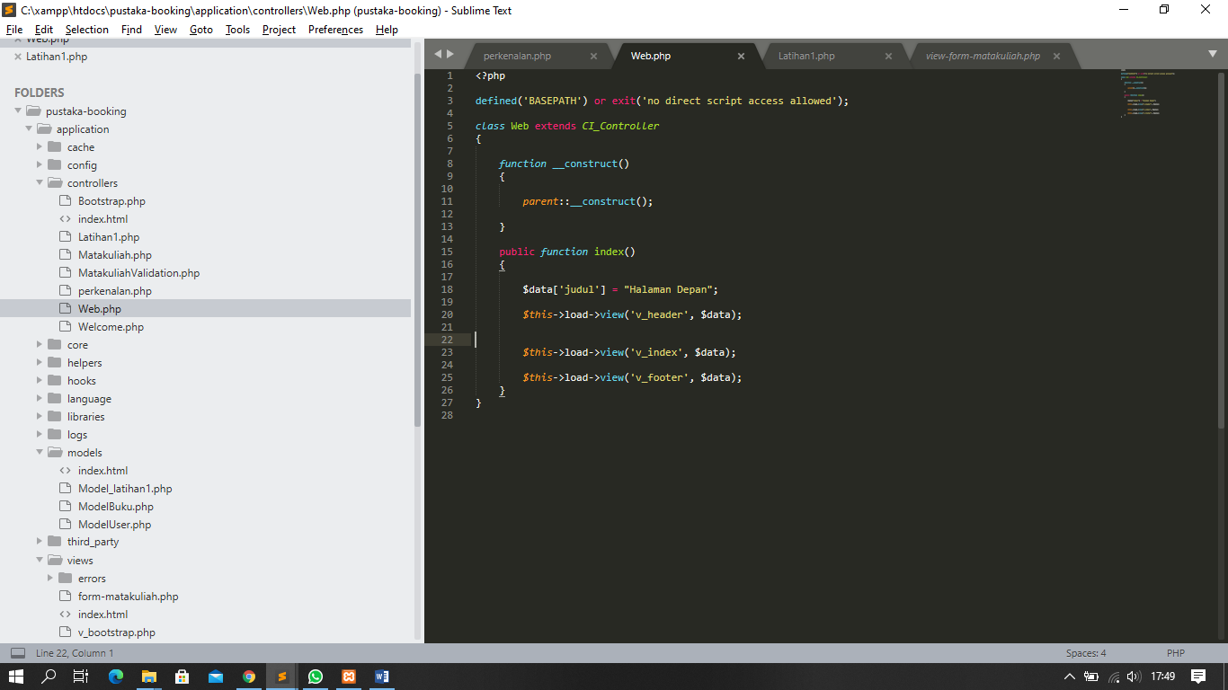

v_header.php - application/view

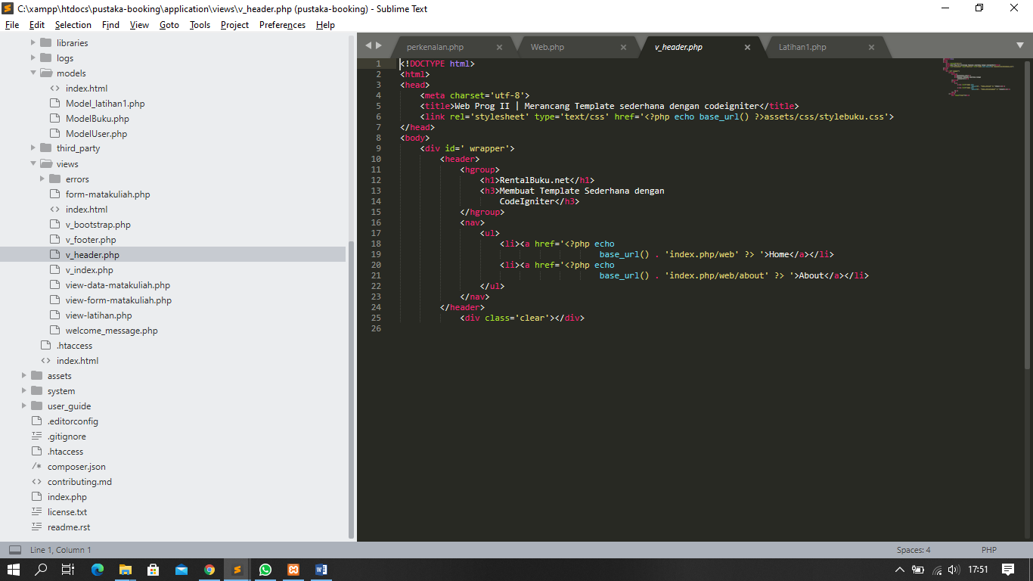

v_index.php => application/view

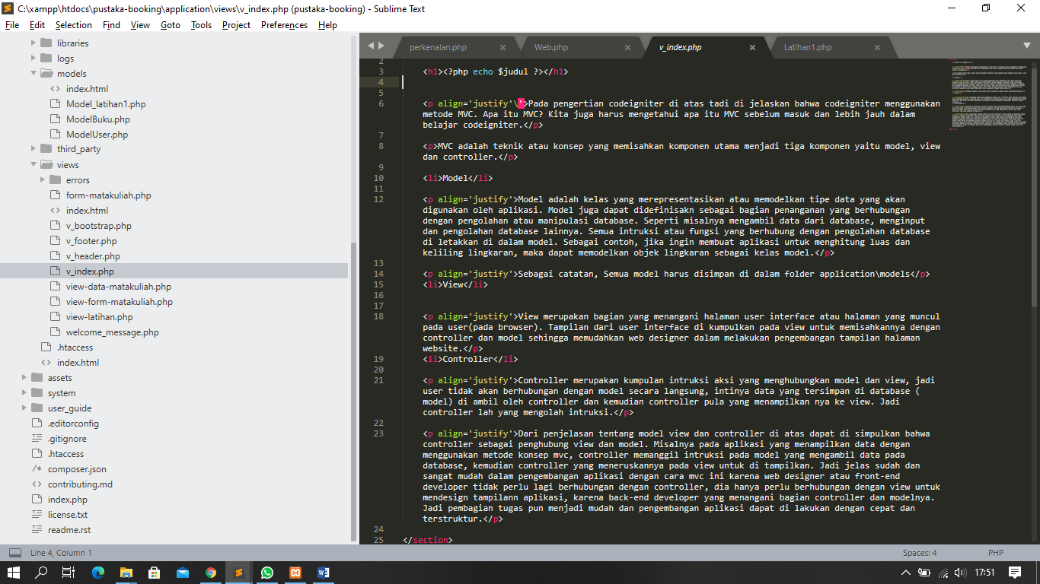

v_footer.php = > application/view

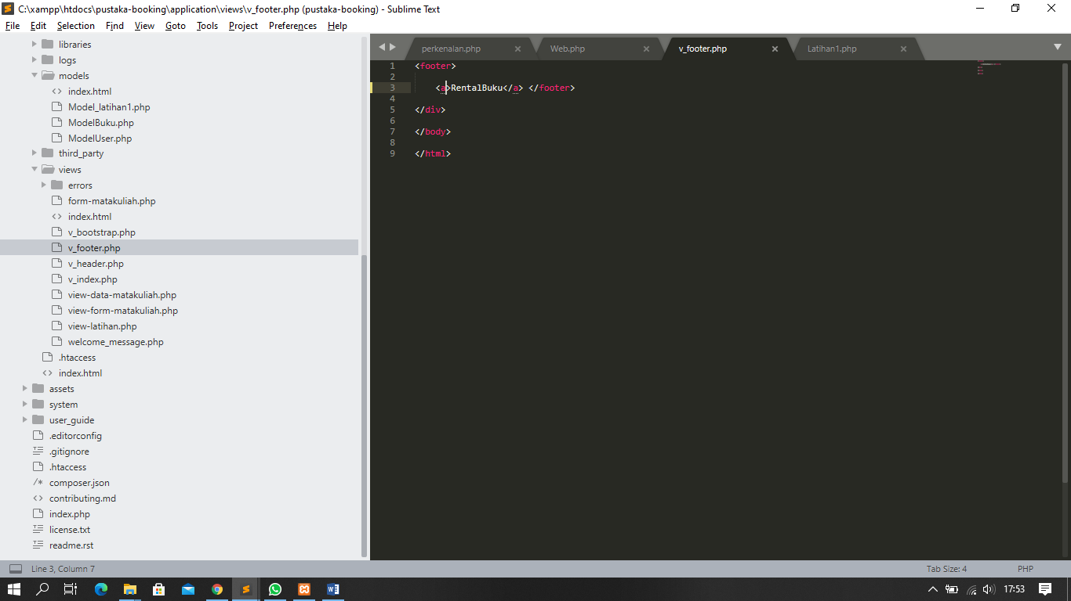

stylebuku.css => assets/css

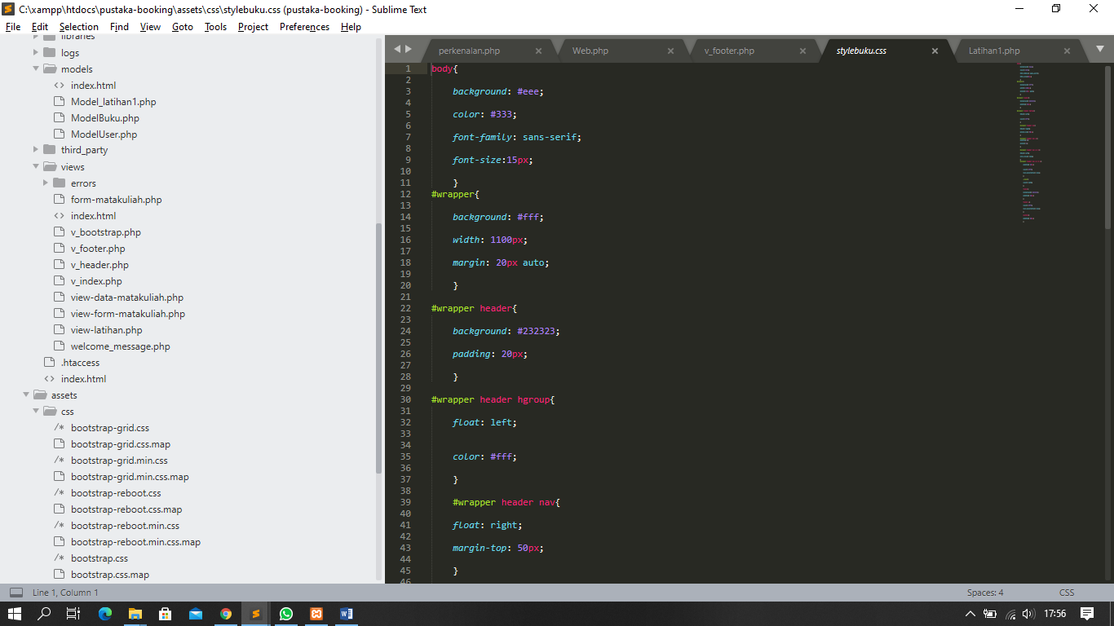

1. URL

<http://localhost/pustaka-booking/web>

1. Screeenshot Hasil

